**EUROPEAN FEDERATION of SHAR PEI CLUBS**

**COMMEMORATIVELONGEVITY CERTIFICATE**

**Issued as part of EFSPC Longevity Month**

**OCTOBER 2024**

**Application Form**

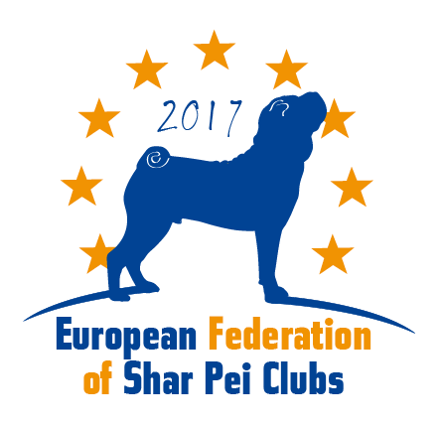

**Information about the owner:**

Name of Owner: …………………………………………………………………………………………………………………………………………….  
Country: ………………………………………………………………………………………………………………………………………………………  
Email and telephone number: …………………………………………………………………………………………………………………………  
**_________________________________________________________________________________________**

**Information about the dog:**

**Name of Dog:** ……………………..…………………………………………………………………………………..……………………..……………...

**Name of Breeder:** ………………………………………………………………. **Country:** …………………………………………………………

**Date of birth:** (day/month/year)………………………… **Date of death:** (day/month/year)…………………………

**Registration number (Pedigree number)**…………………………………………………………………………………..…………………….

**Gender:** male female **Color**: ……………………………………. **Coat type**: …………………………………………..

**Number of produced offspring:** ……………  
*Optional – Health test results*: ……………………………………………………………………………………………………………………….

**_________________________________________________________________________________________**

*By sending this application form, I, the undersigned, agree that EFSPC may collect, store, use, and disclose the provided personal data and information on the EFSPC web page, social media, in collected statistics and in any future publications.   
I confirm that, to the best of my knowledge, the provided information is true and verifiable.*

*….......................................................... Date and Signature of Owner*

**_________________________________________________________________________________________**

**PLEASE NOTE:**

**The Commemorative Certificate of Longevity is issued ONLY during October 2024 as part of the EFSPC Longevity Month!**

The Commemorative Certificate of Longevity is issued free of charge to owners or breeders worldwide, in memory of shar-pei that had reached the age of at least 10 years old, and have passed away without receiving a Certificate of Longevity.

***To apply - please send this application form to Viktoria Potapkina longevity@sharpeifederation.eu,   
with the following documents attached:***

* Completed and signed Commemorative Certificate of Longevity Application Form
* Copy of Pedigree (with the name of owner and breeder clearly visible)
* Photo of the dog
* Confirmation of death – *select below which confirmation you will include:*
* *Death certificate*
* *Veterinary confirmation*
* *Photo of last vaccination date in pet passport*
* *Screenshot of last social media post (with date clearly visible)*
* *Confirmation from 2 “witnesses” who can confirm the dog’s age:*

|  |  |
| --- | --- |
| **Witness #1:**  *Name: ………………………………………….…………………………*  *Email:……………………………………………………………………..*  *Relationship to dog owner:…………………………………….*  Signature: ……………………………………………………………… | **Witness #2:**  *Name: ………………………………………….…………………………*  *Email:……………………………………………………………………..*  *Relationship to dog owner:…………………………………….*  Signature: ……………………………………………………………… |